- On your main page when you first log you are logged onto the top tab called Pages. On this page, there are different boxes located on the page with green headers. Find the one that says “Tasks” in the upper left had corner of the green header.
- Select the “Initiate” button located in the “Tasks” box in the right hand corner. A popup window will appear with a drop down menu. Select the “Contact and Medical Emergency Information, Permission Sign-off” workflow from the list in the menu. Select the magnifying glass and select the student you would like to complete the workflow for. Please note that you will need to go through this process for each student you have in the school system. After selecting the student, select the next button located at the bottom right hand corner of the screen.
- Please complete the information for each tab in the workflow.
- The Guardians tab list parents or guardians responsible for the student. You can update any information about a specific guardian or parent by selecting the name and making any necessary changes and select ok.
- The Contacts tab should list people who will be contacted in case of a medical emergency and the parents or guardians are not available.
- The Emergencies tab list information about your Family Physician and Dentist.
- The Consents and Releases tabs provide the school with information on what you consent to and what information can be released about your student. If you check any of the boxes in the Releases tab, this means you do NOT want your student to be a part of something.

- At the bottom of the Release, Computers, Handbook and 1:1 Device tab, your initials are required in the field pf Digital Signature before selecting the next button at the bottom right hand corner of the page otherwise a popup stating “Value required for field Signature” will appear asking you to put your initials in the box before moving forward. Once you have done this, select next and then finish.
Below are visuals to help guide you through the process.

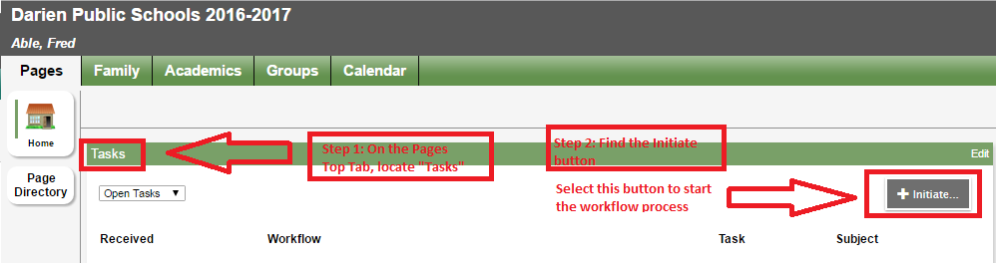
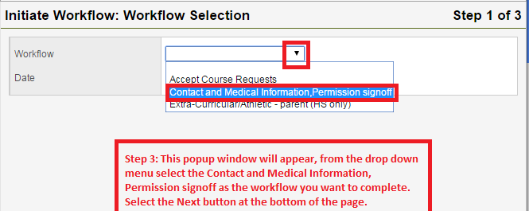
Select the student using the Spy glass you would like to complete the workflow for and then select ok.
