How to access Published Report Cards in Aspen

- Log onto your student or parent portal Aspen account at: aspen.darienps.org
- Stay on the main page when you log in which is the “Pages” tab.
- Locate the Published Reports widget on the lower right hand side near the bottom of the page.
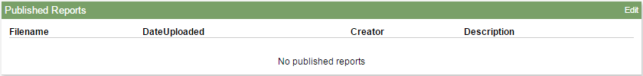
- You will receive an email stating report cards have been published and can be viewed in the Published reports area of Aspen. You'll see a filename, date uploaded, creator, and description.
- Click next to the file name you want to access.
- In the dialog box, do one of the following:
- Click Open to view this report.
- Click Save to save this report to your computer; then navigate to a location. Your report will appear.

